

Uniform Plumbing Code (UPC)

International Plumbing Code (IPC)

National Standard Plumbing Code (NSPC)

March 2021

WSA’s Model Plumbing Code Update

2018 Editions

Table of Contents

Acronyms, Terms and Definitions 3

Model Plumbing Codes 6

Where the Codes are Adopted 6

Model Code Digests 7

Uniform Plumbing Code – 2018 7

HGIs and GRDs in UPC 7

GGIs in UPC 10

FOG Disposal Systems 11

International Plumbing Code – 2018 11

HGIs, GRDs, and FOG Disposal Systems in IPC 11

GGIs in IPC 12

National Standard Plumbing Code – 2018 12

HGIs and GRDs in NSPC 13

GGIs in NSPC 13

# Acronyms, Terms and Definitions

A2LA: American Association of Lab Accreditation; provides laboratory testing and certification accreditation services.

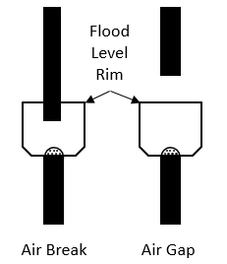Air Break: A piping arrangement in which a drain from a fixture, appliance or device discharges indirectly into another fixture, receptacle or interceptor at a point below the *flood level rim* and above the trap seal.

Air Gap: The unobstructed vertical distance through the free atmosphere between the outlet of the waste pipe and the *flood level rim* of the receptacle into which the waste pipe is discharging.

ANSI: American National Standards Institute; ensures an open consensus standards development process.

ANAB: ANSI-ASQ National Accreditation Board; provides laboratory testing and certification accreditation services.

ASME: American Society of Mechanical Engineers; promotes the art, science & practice of multidisciplinary engineering and allied sciences around the globe. Previously developed, administered and published ASME A112.14.3, A112.14.4, and A112.14.6 for grease interceptors – transferred joint ownership of all three standards to CSA/ICC in 2017.

ASPE: American Society of Plumbing Engineers; an international organization for professionals skilled in the design, specification and inspection of plumbing systems. Publishes the Plumbing Engineering Design Handbook series in four volumes.

CSA: Canadian Standards Association; a global provider of testing, inspection and certification services for products from a wide range of market sectors, a leader in safety and environmental certification for Canada and the US, and one of the largest standards development organizations in North America.

CSO: Combined Sewer Overflow; a backup in a sewer system designed to carry both sanitary waste and storm water to a POTW for treatment.

DFU: Drainage Fixture Unit; a measure of the probable intermittent discharge into the drainage system by various types of plumbing fixtures. The value assigned to any fixture depends on its volume rate of drainage discharge, on the time duration of a single drainage operation and on the average time between successive operations.

Effluent: Wastewater discharged to a private or public sewer system.

FC or FCD: Flow control or flow control device. May be vented external or integral (built-in) types.

Flow Rate: A measurement of the volume of a liquid over time. Typically identified as gallons-per-minute in drainage waste systems.

FOG Control Device: Developing terminology used as an alternative generic description for grease interceptors found in certain FOG ordinances, i.e. Miami-Dade County.

FOG: Fats, Oils and Grease – Organic polar compounds derived from animal and/or plant sources that contain multiple carbon chain triglyceride molecules. FOG normally refers to the byproduct of preparing and cooking food.

FOG disposal system: A grease interceptor that reduces non-petroleum fats, oils and grease in effluent by separation, mass and volume reduction.

FSE: Food Service Establishment; any building, vehicle, place, or structure, or any room or division in a building, vehicle, place, or structure where food is prepared, served, or sold for immediate consumption on or in the vicinity of the premises; called for or taken out by customers; or prepared prior to being delivered to another location for consumption.

GPM: Gallon per minute; a calculation of flow by volume.

GGI: Gravity Grease Interceptor; a plumbing appurtenance or appliance that is installed in a sanitary drainage system to intercept non-petroleum FOG from wastewater discharge and is identified by volume, 30-minute retention time, baffle(s), not less than two-compartments, a total volume of not less than 300 gallons, and gravity separation.

GRD: Grease Removal Device; a hydromechanical grease interceptor that automatically, mechanically removes non-petroleum FOG from the interceptor, the control of which are either automatic or manually initiated.

Grease Interceptor: A generic term used in the industry to refer to any of the common types of devices including HGIs, GGIs, and GRDs.

HGI: Hydromechanical Grease Interceptor; a plumbing appurtenance or appliance that is installed in a sanitary drainage system to intercept nonpetroleum FOG from a wastewater discharge and is identified by flow rate, and separation and retention efficiency. The design incorporates air entrainment, hydromechanical separation, interior baffling, and / or barriers in combination or separately, and one of the following:

A – External flow control, with air intake (vent): directly connected

B – External flow control, without air intake (vent): directly connected

C – Without external flow control, directly vented

D – Without external flow control, indirectly connected

IAPMO: International Association of Plumbing and Mechanical Officials; provides code development assistance, education, plumbing and mechanical product testing and certification, building product evaluation and a manufacturer-preferred quality assurance program. Develops, administers and publishes the UPC, and IAPMO/ANSI Z1001 and IGC 273 for grease interceptors.

IAS: International Accreditation Service; a subsidiary of ICC; provides laboratory testing and certification accreditation services.

ICC: International Code Council; develops model codes and standards used in the design, build and compliance process to construct safe, sustainable, affordable and resilient structures. Develops, administers and publishes the IPC.

Influent: Wastewater that flows into a grease interceptor or pretreatment device.

IPC: International Plumbing Code.

NAPHCC: National Association of Plumbing Heating and Cooling Contractors; formerly developed, administered and published the NSPC (acquired by IAPMO).

NPCC: National Plumbing Code of Canada.

NPDES: National Pollution Discharge Elimination System; EPA administered permit program regulating wastewater authorities.

NRC: National Research Council; the primary national research and technology organization of the Government of Canada, in science and technology research and development.

NSF: National Sanitation Foundation (aka NSF International); independently tests, audits, certifies, trains and consults for the food, water, health science, sustainability and consumer product sectors. Accredited third-party testing laboratory, certification and listing agency for ASME A112.14.3, A112.14.4, CSA B481 Series, and PDI G101. Develops, administers and publishes NSF SE 15741 for grease interceptors.

NSPC: National Standard Plumbing Code.

NVLAP: National Voluntary Laboratory Accreditation Program; administered by National Institute of Standards and Technology; provides laboratory testing and certification accreditation services.

PDI: Plumbing and Drainage Institute; comprised of a group of member organizations, each of which is engaged in the manufacture of products for the plumbing industry. Develops, administers and publishes PDI G101.

POTW: Publicly Owned Treatment Works; a term used for a sewage treatment plant that is owned, and usually operated, by a government agency.

Pretreatment: the treatment of wastewater by commercial and industrial facilities to remove harmful pollutants before being discharged to a sewer system under the control of a POTW.

SSO: Sanitary Sewer Overflow; a backup in a sewer system designed to take separated sanitary wastewater to a POTW for treatment.

Stakeholder: A person or party that has an interest in the subject area and can affect or be affected by the subject area, i.e. wastewater authorities or plumbing code officials.

UPC: Uniform Plumbing Code.

Velocity: A measurement of the speed a fluid travels in distance over time. Typically identified as feet-per-second in drainage waste systems.

# Model Plumbing Codes

The purpose of a model code is to provide a set of requirements that represent best practices from experienced professionals that jurisdictions can adopt in whole or in part, rather than having to develop their own. This provides consistency in building design and performance and reduces the cost of constructing and maintaining structures across jurisdictional boundaries.

These codes are amended and updated then republished on a three-year cycle and typically have only minor amendments or changes in the interim as addendums. There are four model plumbing codes promulgated in North America:

* Uniform Plumbing Code (UPC)
* International Plumbing Code (IPC)
* National Standard Plumbing Code (NSPC)

## Where the Codes are Adopted

The criteria used by both the International Association of Plumbing and Mechanical Officials (IAPMO) and the International Code Council (ICC) in determining the number of states in which the UPC or IPC are in use or adopted allows both entities to claim some of the same states as their own. This is made possible because, while some states do not have statewide adoption of codes, both IAPMO and ICC will claim that state as their own if even only one jurisdiction within the state has adopted their code. Figure 2 illustrates what the map looks like currently.

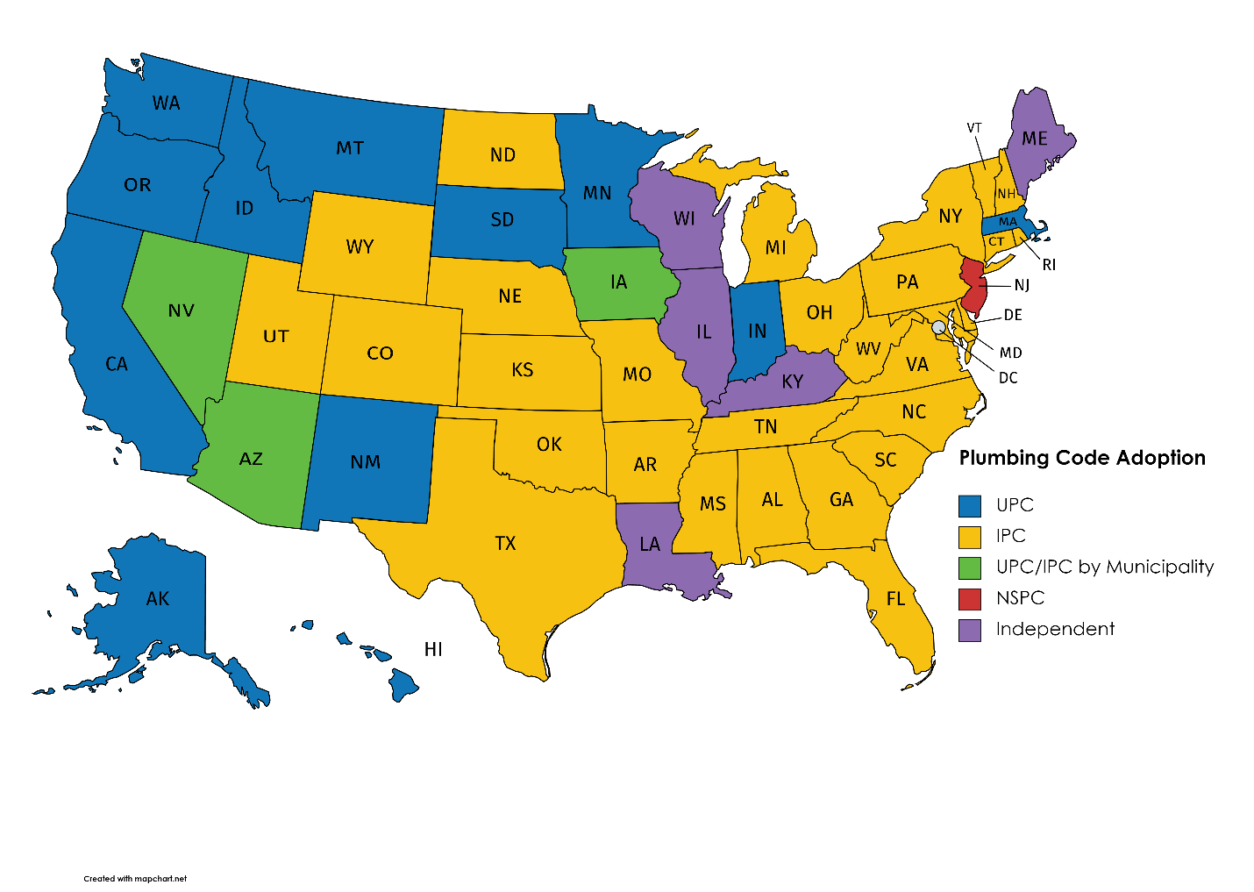

*Figure 2: Map showing the primary plumbing code adopted by each state or province.*

## Model Code Digests

Following is a digest of each of the model codes and their respective requirements governing grease interceptors. Plumbing codes may or may not be superseded by local pretreatment ordinances, policies, or bylaws that govern the discharge of FOG to sanitary sewer collection systems. It is always advisable to check with the local wastewater authority to ensure that a grease interceptor that may be suitable for a project according to the plumbing code is also suitable according to the wastewater authority.

### Uniform Plumbing Code – 2018

The UPC is a model code developed by IAPMO. The first edition of this code was officially adopted by the Western Plumbing Officials Association (now IAPMO) in 1945. The code provides the following requirements governing grease interceptors:

#### HGIs and GRDs in UPC

HGIs and GRDs shall be tested and rated in accordance with ASME A112.14.3, A112.14.4, CSA B481.1, PDI G101, or PDI G102. An interceptor only needs to be certified to one of these standards to be compliant with the code. HGI installation is permitted indoors or outdoors. Dishwashers and food waste disposers are prohibited from discharging into a grease interceptor. Food waste disposers are allowed to discharge to a grease interceptor that is designed to receive food waste discharges.

Sizing for HGIs is determined by either using the pipe diameter of the grease waste piping connected to the inlet of the interceptor (pipe diameter sizing) or by the capacity of all the connected fixtures by volume (fixture volume sizing).

TABLE 1014.2.1

HYRDROMECHANICAL GREASE INTERCEPTOR SIZING USING GRAVITY FLOW RATES1

|  |  |  |  |
| --- | --- | --- | --- |
| Pipe Size (inches) | Full-Pipe Flow (GPM)2 | One-minute drainage period (GPM) | Two-minute drainage period (GPM) |
| 2 | 20 | 20 | 10 |
| 3 | 60 | 75 | 35 |
| 4 | 125 | 150 | 75 |
| 5 | 230 | 250 | 125 |
| 6 | 375 | 400 | 200 |
| Notes  1 For interceptor sizing by fixture capacity see the example below (Example 1014.2.1).  2 1/4 inch per foot based on Manning's formula with friction factor N = 0.012. | | | |

*Table 1: UPC Table 1014.2.1*

Table 1 (1014.2.1) came originally from PDI G101 and was expanded to include five and six-inch diameter pipes. While the code provides the option of a one or two-minute drainage period in determining the minimum flow rate for the specified HGI, it does not provide a published explanation as to when to use one or two minutes. PDI introduced the one-minute/two-minute drainage periods, explaining that the two-minute drainage time allows a “convenience factor” that can be used in situations where the physical size of a HGI sized for one-minute is too large to be accommodated. Sizing the HGI for a two-minute drainage period would result in a unit that would be half the size and therefore much smaller. However, reducing the size of the unit by half also reduces the grease storage capacity available to the FSE, which would double the maintenance frequency. Thus, while a unit sized to a two-minute drainage period is half as big it will have to be cleaned twice as often.

The pipe diameter for a sanitary drainage system is determined by the number of drainage fixture units (DFU) for the fixtures connected to the sanitary system. A DFU represents the potential intermittent flow from a fixture and one DFU is equivalent to one lavatory. The code assigns a DFU value to each kind of fixture routed to the sanitary system and when they are added together a table is provided in Chapter 7, which is used to determine the diameter of the drainage pipe (see Table 3 below).

The one-minute drainage period is based on the maximum flow-rate that can be discharged in a horizontal drainage pipe of a given diameter. Drainage waste piping systems are not designed to operate at 100 percent of the drainage pipe’s capacity. To allow for proper gravity flow a drainage system needs air above the wastewater and therefore systems are designed to operate at not more than 50 percent of the drainage pipe’s capacity at peak flow. The two-minute drainage period allows for the selection of a grease interceptor based on the design capacity of the drainage system instead of the maximum capacity of the system, which reflects real-world practices.

*Figure 3: UPC Example 1014.2.1*

Figure 3 (1014.2.1) illustrates sizing and selecting a HGI by the capacity of the connected fixtures in volume. Multiplying the length times the width times the depth of a sink gives the volume in cubic inches. To convert cubic inches into gallons, divide by 231. The fill factor assumes that a sink must have room for dishware and will not be filled to more than 75 percent of its total capacity. The option of sizing the interceptor to a one or two-minute drainage period is provided as well.

Deciding on whether to use a one or two-minute drainage period when using the fixture volume sizing method is not as straight forward as it is with using the pipe diameter sizing method. Fixtures discharge through a tailpiece that is normally 1-1/2 inches in diameter. If the sink volume for a single compartment sink is 50 gallons, it will not discharge 50 gallons in one minute through a 1-1/2-inch tailpiece since the maximum flow that can discharge through the tailpiece is only about 18 GPM. In the example above, the sink volume is based on a two-compartment sink, each of which would have a 1-1/2-inch tailpiece and if discharged simultaneously would flow close to 40 gallons in one minute.

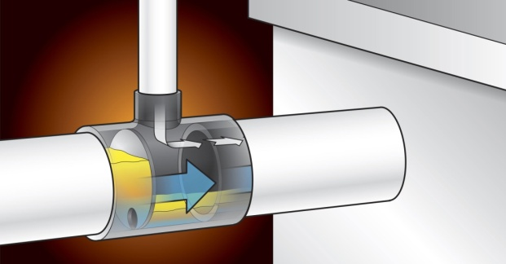

A flow control device helps to ensure that a HGI will not get overwhelmed by the entering flow, whether using a one or two-minute drainage period. It may be perfectly acceptable to use a two-minute drainage period if the fixtures are all directly connected to the interceptor.

*Figure 4: External Vented Flow Control*

Indirectly connected fixtures such as floor drains and floor sinks, which have an air gap or air break, can allow backups to happen in the kitchen from the HGI, particularly when using a two-minute drainage period. In the example above, using a two-compartment sink, if both compartments discharge simultaneously and the interceptor is sized based on a two-minute drainage period, while the sinks could discharge at nearly 40 GPM, the HGI will only accept 25 GPM and if there is an indirectly connected fixture, that extra flow is going to flood onto the kitchen floor through the indirectly connected fixture. One solution may be to install the flow control upstream of the indirectly connected fixture or flow restrictors on multiple fixtures that could discharge simultaneously into the indirectly connected fixture to ensure that the maximum flow discharging to the HGI does not exceed the two-minute flow rate it was sized for.

Section 1014.1.3 of the code addresses Food Waste Disposers (FWD) and Dishwashers (DW). The code states that, “no food waste disposer or dishwasher shall be connected or discharge into a grease interceptor.” An exception is made to allow FWDs to discharge through a grease interceptor that is designed to receive such discharge, e.g., GGIs.

This is not a good strategy to keep grease out of the sanitary sewer system. FWD’s have been documented to discharge the highest concentrations of FOG in a commercial kitchen. Careful consideration should be given to disallowing these fixtures or requiring them to be routed to a grease interceptor to mitigate the impact they have on FOG discharges.

#### GGIs in UPC

GGIs shall comply with IAPMO/ANSI Z1001, which is a design standard that contains no performance test. Dishwashers shall be permitted to discharge to a GGI. Sizing GGIs shall be by DFU to determine the liquid gallon holding capacity (minimum 500 gallons) according to the Table 2 (Table 1014.3.6).

**TABLE 1014.3.6**

**GRAVITY GREASE INTERCEPTOR SIZING**

|  |  |
| --- | --- |
| Drainage Fixture Units  (DFU)1,3 | Interceptor Volume2  (gallons) |
| 8 | 500 |
| 21 | 750 |
| 35 | 1000 |
| 90 | 1250 |
| 172 | 1500 |
| 216 | 2000 |
| 307 | 2500 |
| 342 | 3000 |
| 428 | 4000 |
| 576 | 5000 |
| 720 | 7500 |
| 2112 | 10000 |
| 2640 | 15000 |
| 1 The maximum allowable DFUs plumbed to the kitchen drain lines that will be connected to the grease interceptor | |
| 2 This size is based on: DFUs, the pipe size from this code; Table 703.2; Useful Tables for flow in half-full pipes (ref: Mohinder Nayyar Piping Handbook, 3rd Edition, 1992). Based on 30-minute retention time (ref: George Tchobanoglous and Metcalf & Eddy. Wastewater Engineering Treatment, Disposal and Reuse, 3rd Ed. 1991 & Ronald Crites and George Tchobanoglous. Small and Decentralized Wastewater Management Systems, 1998). Rounded up to nominal interceptor volume. | |
| 3 Where the flow rate of directly connected fixtures(s) or appliance(s) have no assigned DFU values, the additional grease interceptor volume shall be based on the known flow rate (GPM) (L/s) multiplied by 30 minutes. | |

*Table 2: UPC Table 1014.3.6*

The calculations used to determine the size of a GGI attempt to use a 30-minute retention time by limiting the maximum number of DFUs that are assigned to a given liquid volume for a GGI.

Where DFUs are not known, the interceptor shall be sized based on the maximum DFUs allowed for the pipe size connected to the inlet of the interceptor. Table 3 (703.2) provides the maximum DFU’s per pipe diameter.

**TABLE 703.2 Drainage Piping (abridged)**

|  |  |
| --- | --- |
| Pipe Size (inches) | Maximum DFUs, Horizontal Drainage Piping |
| 1-1/4 | 1 |
| 1-1/2 | 1 |
| 2 | 8 |
| 2-1/2 | 14 |
| 3 | 35 |
| 4 | 216 |
| 5 | 428 |
| 6 | 720 |
| 8 | 2640 |
| 10 | 4680 |
| 12 | 8200 |

*Table 3: UPC Table 703.2*

#### FOG Disposal Systems

FOG Disposal Systems, including components, materials, and equipment necessary for the proper function of the system, shall be in accordance with ASME A112.14.6. These devices are onsite treatment systems intended to reduce FOG discharges to a maximum of 100 mg/L. They are to be sized and installed in accordance with manufacturer’s instructions.

### International Plumbing Code – 2018

The IPC is a model code developed by the International Code Council. The first edition was published in 1995 making this the youngest of the model codes. The code provides the following requirements governing grease interceptors:

#### HGIs, GRDs, and FOG Disposal Systems in IPC

HGIs, FOG Disposal Systems, and GRDs shall be tested and sized in accordance with ASME A112.14.3, A112.14.4, A112.14.6, CSA B481, PDI G101, or PDI G102. HGIs are permitted to serve as a fixture trap for a single fixture or combination fixture of not more than three compartments when installed per the manufacturer’s installation instructions. Dishwashers (without pre-rinse sinks) must connect to a grease interceptor. **Food waste grinders must be routed directly to the sanitary sewer system** and may not discharge through a grease interceptor. This is a change from previous editions of the code.

Table 4 (1003.3.4.1) lists the *minimum* required capacity for grease interceptors at the stated flow rate. This should *not* be interpreted as a maximum or exact grease capacity required.

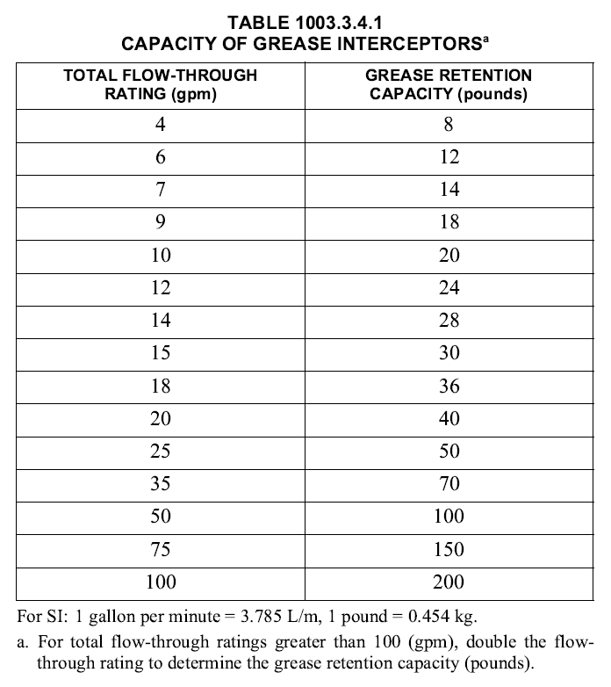The sizing contained in ASME A112.14.3, CSA B481.3 and PDI G101 all use both the pipe diameter and fixture volume methods as described under the UPC section for HGIs above.

*Table 4: minimum grease capacity required*

#### GGIs in IPC

GGIs are to be designed, tested and installed in accordance with IAPMO/ANSI Z1001. They must be 500 gallons or larger in capacity, and must be sized by peak flow rate to have a 30-minute retention time. GGIs with FOG Disposal Systems shall be designed and tested in accordance with both ASME A112.14.6 and IAPMO/ANSI Z1001.

### National Standard Plumbing Code – 2018

The NSPC is a model code developed by the National Association of Plumbing-Heating-Cooling Contractors (NAPHCC). The roots of this code go back to 1933 when the National Association of Master Plumbers first published the Standard Plumbing Code. That code was supported only until 1942 after which, the National Plumbing Code Coordinating Committee’s work led to the adoption of A40.8 as a standard or model plumbing code in 1955. Efforts to revise this new code ultimately failed and in 1971, the NAPHCC published the National Standard Plumbing Code, which followed the format and sequence of A40.8.

In 2017, IAPMO acquired the publishing rights to the NSPC, encompassing all previous editions, the upcoming 2018 edition, and all future editions. IAPMO is maintaining the National Standard Plumbing Code Committee’s close working relationship with the plumbing industry to maintain a document of minimum requirements for plumbing systems that reflect current practices, materials, and techniques, consistent with public health and safety.

The code provides the following requirements governing grease interceptors:

#### HGIs and GRDs in NSPC

HGIs shall comply with ASME A112.14.3 or PDI G101, and GRDs shall comply with ASME A112.14.4. Sizing shall be in accordance to PDI G101, Table 6.2.10 of the code or the manufacturer’s instruction. Where a food waste grinder discharges through a HGI it must be routed first through a solid’s interceptor upstream of the interceptor. A HGI or GRD may serve as a trap for an individual fixture if the developed length of the drain between the fixture and the interceptor does not exceed four feet horizontally and 30 inches vertically. Dishwashers are permitted to be routed to an HGI. Sizing must be in accordance with PDI G101 (fixture volume or pipe diameter with a one or two-minute drainage period), Table 6.2.10 in the code, or the manufacturer’s instructions. Table 5 (6.2.10) illustrates the alternate sizing method in the code.

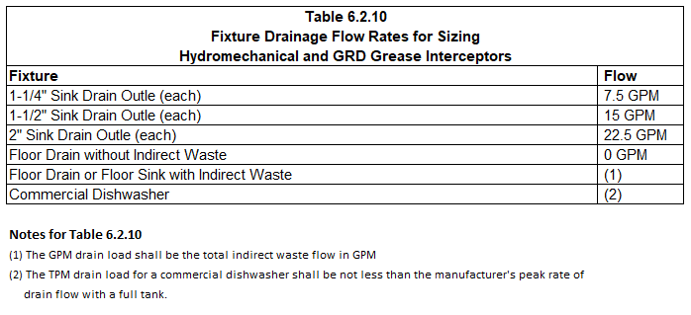

*Table 5: Flow rates assigned by Sink Drain Outlet Diameter*

#### GGIs in NSPC

GGIs shall be sized and designed by a locally registered and licensed design professional. Prefabricated GGIs shall comply with IAPMO/ANSI Z1001. GGIs shall be sized by gallons factoring a 30-minute retention time at half pipe flows per Appendix K in the code, with an extra 25% storage factor for FOG and solids. Food waste grinders and dishwashers may discharge directly to a GGI.